### 

### Semester One Examination, 2018

### Question/Answer booklet

# Yr 12 SPECIALIST

**UNIT 3**

## Section Two:

## Calculator-assumed

|  |
| --- |
|  |

Marking Key

## Time allowed for this section

Reading time before commencing work: ten minutes

Working time: one hundred minutes

## Materials required/recommended for this section

***To be provided by the supervisor***

This Question/Answer booklet

Formula sheet (retained from Section One)

***To be provided by the candidate***

Standard items: pens (blue/black preferred), pencils (including coloured), sharpener, correction fluid/tape, eraser, ruler, highlighters

Special items: drawing instruments, templates, notes on two unfolded sheets of A4 paper, and up to three calculators approved for use in this examination

## Important note to candidates

No other items may be taken into the examination room. It is **your** responsibility to ensure that you do not have any unauthorised material. If you have any unauthorised material with you, hand it to the supervisor **before** reading any further.

**Structure of this paper**

|  |  |  |  |  |  |
| --- | --- | --- | --- | --- | --- |
| Section | Number of questions available | Number of questions to be answered | Working time (minutes) | Marks available | Percentage of examination |
| Section One:  Calculator-free | 8 | 8 | 50 | 50 | 35 |
| Section Two:  Calculator-assumed | 21 | 21 | 100 | 95 | 65 |
|  |  |  |  | **Total** | 100 |

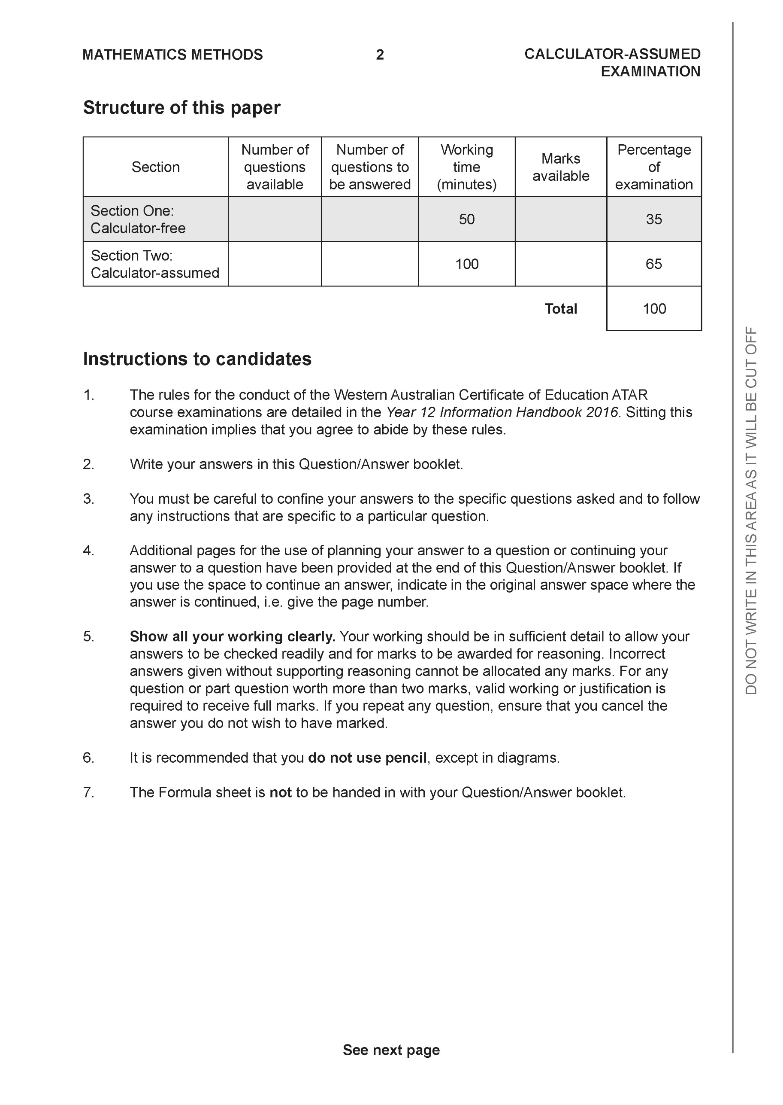

**Section Two: Calculator-assumed (95 Marks)**

This section has **13** questions. Answer **all** questions. Write your answers in the spaces provided.

Spare pages are included at the end of this booklet. They can be used for planning your responses and/or as additional space if required to continue an answer.

● Planning: If you use the spare pages for planning, indicate this clearly at the top of the page.

● Continuing an answer: If you need to use the space to continue an answer, indicate in the original answer space where the answer is continued, i.e. give the page number. Fill in the number of the question that you are continuing to answer at the top of the page.

Working time: 100 minutes.

**Question 9 (4 marks)**

Using vectors and the vector property  , prove the following inequality



|  |
| --- |
| **Solution** |
|  |
| **Specific behaviours** |
| 🗸 uses dot product to find magnitude of sum of vectors  🗸 expands dot product and collects like terms  🗸 uses upper limit for dot product of the two vectors to generate inequality  🗸 uses difference of two squares to prove inequality |

**Question 10 (9 marks)**

Consider the following system of linear equations where  are constants.



Determine the values of :

(a) for which there is a unique solution (4 marks)

|  |
| --- |
| **Solution** |
| Unique |
| **Specific behaviours** |
| 🗸 eliminates one variable from two equations  🗸 eliminates two variables from one equation  🗸 identifies all allowed values for m  🗸 states that all real values of p allowed |

(b) for which there are infinite solutions. (3 marks)

|  |
| --- |
| **Solution** |
|  |
| **Specific behaviours** |
| 🗸 shows that a line of zeros required or gives reasoning  🗸 states value for m  🗸 states value for p |

(c) for which there are no solutions. (2 marks)

|  |
| --- |
| **Solution** |
|  |
| **Specific behaviours** |
| 🗸 states value of m  🗸 states all allowed values of p |

**Question 11 (4 marks)**

Consider the plane  as shown below.

Determine the distance of point P  from the plane to two decimal places.

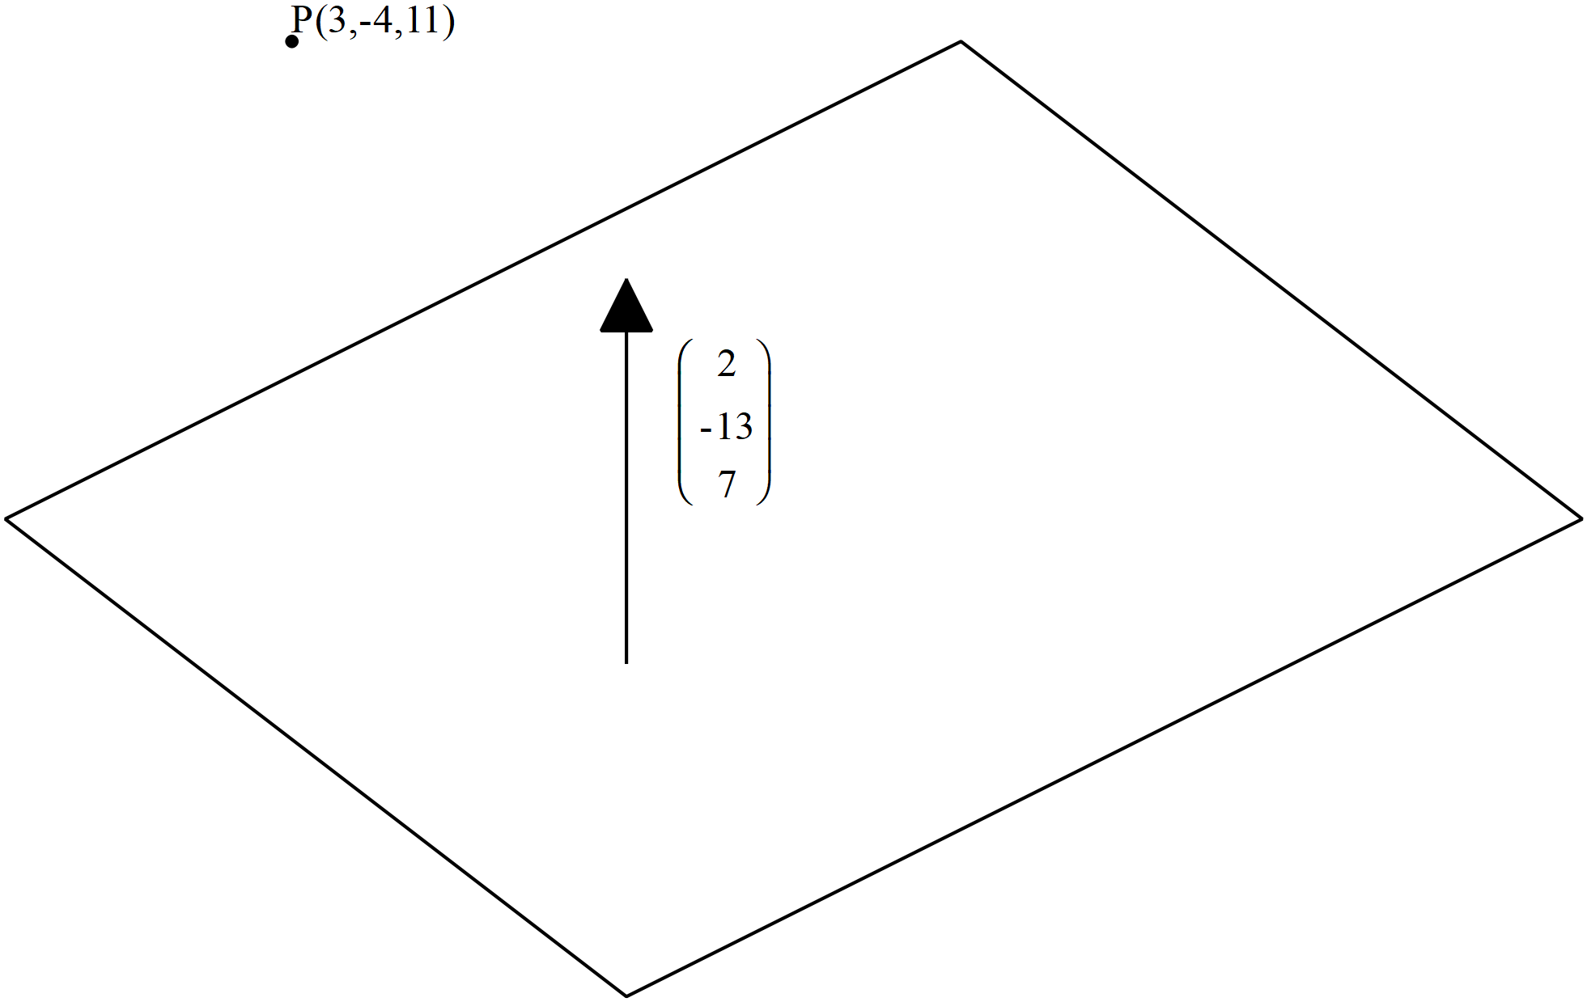

|  |
| --- |
| **Solution** |
| Line through P and parallel to normal |
| **Specific behaviours** |
| 🗸 determines vector equation of line through P  🗸 subs vector eqn of line into plane and uses dot product equaling 15  🗸 solves for parameter  🗸 determines distance (no need to round to 2 dp)  **OR**  🗸determines any point on plane B  🗸determines vector PB  🗸dots this vector with unit normal  🗸determines distance |

**Question 12 (4 marks)**

Given that  use cross product to determine the distance of point P  from the line  to one decimal place.

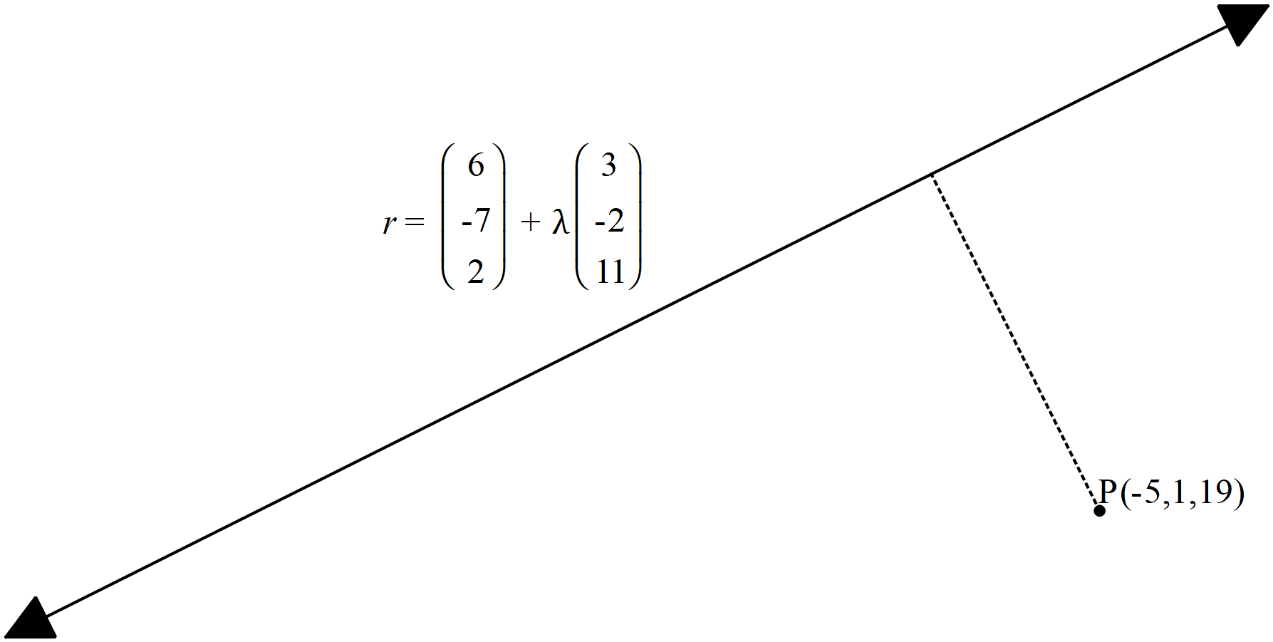

|  |
| --- |
| **Solution** |
|  |
| **Specific behaviours** |
| 🗸 determines vector AP  🗸 uses unit vector parallel to line  🗸 uses cross product of the above vectors  🗸 determines magnitude of cross product ( no need to round to one dp) |

**Question 13 (4 marks)**

The three vertices of a triangle have position vectors . Given that 

Show that the area of the triangle is given by 

|  |
| --- |
| **Solution** |
|  |
| **Specific behaviours** |
| 🗸 uses area formula for triangle using adjacent sides and included angle  🗸 uses difference vectors and magnitude of cross product to determine this area  🗸 uses that a vector crossed itself is zero and changing order negates sign  🗸 summarises to show required result |

**Question 14 (6 marks)**

Consider the polynomial  where  are real constants. Determine the values of given the following information for 

 is a factor of .

When is divided by  there is a remainder of 165

 and 

|  |
| --- |
| **Solution** |
| Conjugate of  is also a root |
| **Specific behaviours** |
| 🗸 uses conjugate to determine new factor  🗸 uses factor of x-2  🗸 subs x=0 y=32  🗸 subs x=1 y=165  🗸 solves for all linear factors  🗸expands factors to determine coefficients |

575=(x+2)5(23)

**Question 15 (9 marks)**

At noon a rocket is launched from position  km with a velocity of  km/h.

Two hours later a second rocket is launched from position  km with a velocity of  km/h.

Assume that both rockets move with constant velocity at all times and that the rockets

do not collide.

(a) Determine the distance between the rockets at 2:30pm that day to one decimal place

(3 marks)

|  |
| --- |
| **Solution** |
|  |
| **Specific behaviours** |
| 🗸 Uses vector equations for paths of both rockets  🗸 uses appropriate time values  🗸 determines distance apart ( no need to round to 1 dp) |

(b) Determine the times that the distance between the rockets is less than 50 km.

(4 marks)

|  |
| --- |
| **Solution** |
|  |
| **Specific behaviours** |
| 🗸 determines vector equation for rocket in terms of t  🗸 determines vector equation of second rocket for t-2  🗸 determines expression for magnitude of separation in terms of t and equates to 50k  🗸 identifies approx (no need to round) |

(c) Determine the distance of closest approach and the time that this occurs. (2 marks)

|  |
| --- |
| **Solution** |
| Closest distance of 22.14 km at t=2 hours at time 2 pm |
| **Specific behaviours** |
| 🗸 determines minimum value of separation magnitude and states distance  🗸 gives time that is within one minute of correct answer |

**Question 16 (9 marks)**

Consider the complex numbers drawn in the complex plane below.

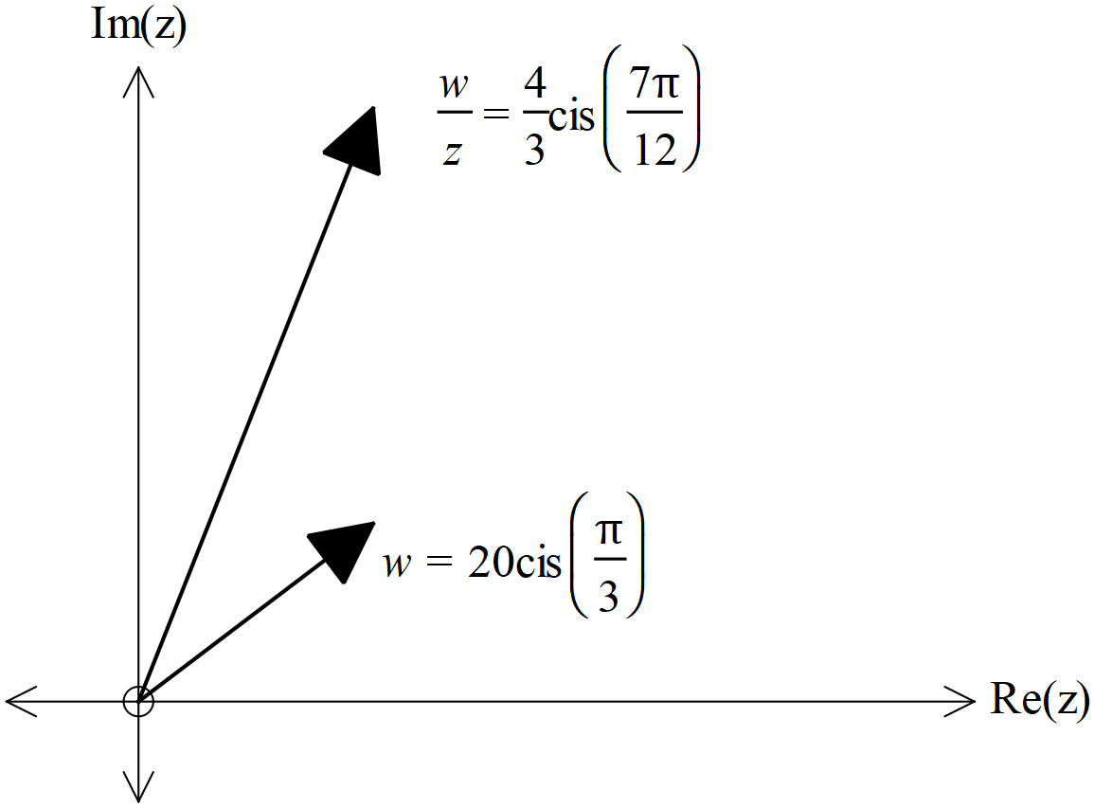

(a) Determine the exact value of  in the form of  (3 marks)

|  |
| --- |
| **Solution** |
|  |
| **Specific behaviours** |
| 🗸 determines modulus for z  🗸 determines Arg for z  🗸 express z in cartesian form (No need to rationalize denominator) |

Consider the equation 

where  and 

(b) Represent the above equation as a triangle in the complex plane below (3 marks)

|  |
| --- |
| **Solution** |
|  |
| **Specific behaviours** |
| 🗸 expresses the first complex number as 5 cis45 on triangle  🗸 shows two complex numbers adding as vectors to give LHS  🗸 third side in triangle represents unknown complex number |

Cont-

(c) Hence or otherwise solve for  to one decimal place. (3 marks)

|  |
| --- |
| **Solution** |
|  |
| **Specific behaviours** |
| 🗸 solves for r using geometry or cosine rule  🗸 solves another angle in triangle  🗸 determines Principal Argument in radians  (No need to round to 1 dp) |

**Question 17 (9 marks)**

Consider a sphere with centre  and radius of  units.

(a) Write down the vector equation for this sphere (2 marks)

|  |
| --- |
| **Solution** |
|  |
| **Specific behaviours** |
| 🗸 uses difference of r from centre  🗸 equates difference to radius |

Consider a line parallel to vector  and containing the point 

where  is a constant.

(b) Write down the vector equation of the line in terms of . (2 marks)

|  |
| --- |
| **Solution** |
|  |
| **Specific behaviours** |
| 🗸 uses parameter  🗸 states correct vector equation |

(c) Determine the possible values of , to 2 decimal places, if the line is a tangent to the sphere..

(5 marks)

|  |
| --- |
| **Solution** |
|  |
| **Specific behaviours** |
| 🗸 subs r from line into vector eqn of sphere  🗸 obtains an equation in terms of a and paremeter  🗸 expands and adds like terms to give a quadratic equation where the  quadratic formula maybe used.  🗸 obtains expression for discriminant and equates to zero solving for a  🗸gives two values for a (no need to give to 2 dp) |
|  |
|  |

**Question 18 (11 marks)**

A particle moves with acceleration  at time  seconds. The initial velocity is  and initial displacement of .

(a) Determine the time(s),, that the particle is travelling parallel to the y axis.

(4 marks)

|  |
| --- |
| **Solution** |
|  |
| **Specific behaviours** |
| 🗸 anti-differentiates to determine velocity  🗸 determines vector constant  🗸 equates i component of velocity to zero  🗸 solves for t in required interval (approx.) |

(b) Determine the first two times that the particle crosses the y axis. (4 marks)

|  |
| --- |
| **Solution** |
|  |
| **Specific behaviours** |
| 🗸 anti-differentiates to determine position vector  🗸 determines vector constant  🗸 equates i component to zero  🗸 solves for t giving first two positive values only (approx.) |

(c) Determine the cartesian equation of the path of a new particle with the following position vector  (3 marks)

|  |
| --- |
| **Solution** |
|  |
| **Specific behaviours** |
| 🗸 obtains sint in terms of x  🗸 uses double angle formula to rearrange y expression  🗸 obtains a cartesian equation (unsimplified) |

**Question 19 (9 marks)**

Consider the function  where  and

 are positive constants with 

(a) Given that the inverse function does exist obtain an expression for 

in terms of  (3 marks)

|  |
| --- |
| **Solution** |
|  |
| **Specific behaviours** |
| 🗸 swaps x and y  🗸 uses quadratic formula or completing the square to solve for inverse  🗸 uses negative as |

(b) Given that there is only one point where  determine the x value

in terms of  (3 marks)

i

|  |
| --- |
| **Solution** |
|  |
| **Specific behaviours** |
| 🗸 equates f(x) to x  🗸 solves using quadratic formula or completing the square to solve for x  🗸 uses negative sign to give one answer for x |

(c) Given that  and ,

determine the function  in terms of  (3 marks)

|  |
| --- |
| **Solution** |
|  |
| **Specific behaviours** |
| 🗸 expresses x in terms of y for h(x)  🗸 subs into composite to give expression in terms of y only  🗸 states g(x) in terms of x only |

**Question 20 (11 marks)**

Consider  drawn below, where each face is a parallelogram. Let  ,  and  with  perpendicular to plane containing vectors .

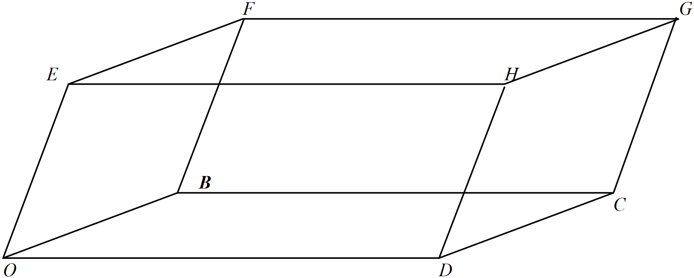

(a) Express each of the vectors  in terms of 

(4 marks)

|  |
| --- |
| **Solution** |
|  |
| **Specific behaviours** |
| 🗸 (one mark for each vector)  🗸  🗸  🗸 |

(b) Express  in terms of  (4 marks)

|  |
| --- |
| **Solution** |
|  |
| **Specific behaviours** |
| 🗸 dots vector with itself to obtain magnitude squared  🗸 recognizes that b.e=0=b.d  🗸 obtains two correct expressions  🗸 obtains all four correct expressions |

Cont-

(c) Hence show that 

(3 marks)

|  |
| --- |
| **Solution** |
|  |
| **Specific behaviours** |
| 🗸 shows that d.e terms all cancel  🗸 shows that each magnitude occurs four times in sum  🗸 shows that LHS=RHS  (Maximum of one mark follow through if expressions in part b are incorrect) |

**Question 21 (6 marks)**

Consider the region defined by  in the complex plane.

(a) Sketch the region on the axes below. (3 marks)

|  |
| --- |
| **Solution** |
|  |
| **Specific behaviours** |
| 🗸 centre of both circles at -3-4i  🗸 radii of both circles correct  🗸 area between circles shaded including circles |

(b) Given that , determine the minimum value of 

In the region in (a).(Give to two decimal places) (3 marks)

|  |
| --- |
| **Solution** |
|  |
| **Specific behaviours** |
| 🗸 uses tangent at top of circle through origin  🗸 determines both  angles in diagram above  🗸 determines minimum argument in allowed interval (Principal) |

Additional working space

Question number:

Additional working space

Question number:

Additional working space

Question number:

**Acknowledgements**